ASSIGNMENT 1

1. Write a JavaScript program that accepts two numbers in two prompts and displays the larger one in the console.

2. Write a JavaScript conditional statement to find the sign of a number. Display an alert box with the specified sign.  
Sample: 3  
Output : The sign is +   
Sample: -5   
Output : The sign is –

3. Write a JavaScript program that accepts five numbers in five prompts and displays the larger one in the console.

4. Write a JavaScript program which computes the average marks of the following students Then, this average is used to determine the corresponding grade.

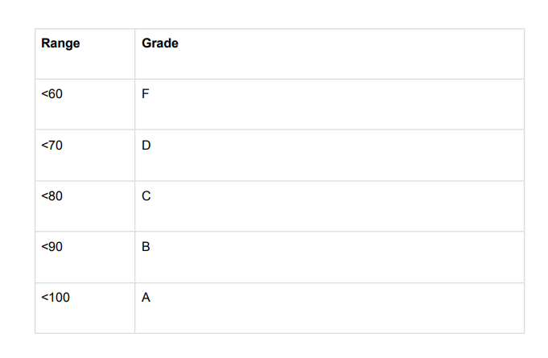The grades are computed as follows :